

**PYTHON PROJECT REPORT**

(Project Semester: January-April 2025)

**Title of the Project: World Economic Indicators Analysis**

**Submitted by:**

**Aditya Raj  
Registration No.: 12310926  
Programme and Section: B.Tech CSE (K23FD)  
Course Code: INT375**

**Under the Guidance of:  
Baljinder Kaur (UID : 27952)**

**Discipline of CSE/IT**  
**Lovely School of Computer Science & Engineering**  
**Lovely Professional University, Phagwara**

**DECLARATION**

I, **Aditya Raj**, student of **Bachelor of Technology (B.Tech)** under CSE/IT Discipline at Lovely Professional University, Punjab, hereby declare that all the information furnished in this project report is based on my own intensive work and is genuine.

Date: 03-April-2025

Signature:   
Registration No.: 12310926  
Name of the Student: **Aditya Raj**

# ****CERTIFICATE****

This is to certify that **Aditya Raj** bearing Registration No. **12310926** has completed **INT375** project titled **“World Economic Indicators Analysis”** under my guidance and supervision. To the best of my knowledge, the present work is the result of her original development, effort, and study.

**Baljinder Kaur**  
**Assistant Professor**  
**School of Computer Science & Engineering**

**Lovely Professional University**  
**Phagwara, Punjab**

**ACKNOWLEDGMENT**

I would like to express my sincere gratitude to **Baljinder Kaur Ma’am**, my project guide, for their invaluable support, guidance, and encouragement throughout the development of this project. Their expert insights and constructive feedback have been instrumental in shaping the project's outcome.

I am also thankful to **Lovely Professional University** for providing a conducive learning environment and access to resources that made this project possible. Additionally, I extend my appreciation to my professors and peers for their continuous motivation and insightful discussions, which greatly enhanced my understanding of the subject.

Lastly, I would like to acknowledge the unwavering support of my family and friends, whose encouragement has been a source of inspiration throughout this journey.

# ****TABLE OF CONTENTS****

1. Introduction
2. Source of Dataset
3. Dataset Preprocessing
4. Analysis on Dataset (for each objective)
   * i. General Description
   * ii. Specific Requirements
   * iii. Analysis Results
   * iv. Visualization
5. Conclusion
6. Future Scope
7. References

# ****1. INTRODUCTION****

In the modern era of data-driven decision-making, policymakers, researchers, and organizations increasingly rely on data analysis to understand global economic trends, country performance, and development progress. One of the most effective techniques for extracting insights from raw datasets is Exploratory Data Analysis (EDA). EDA plays a crucial role in identifying patterns, spotting anomalies, testing hypotheses, and checking assumptions through statistical summaries and visualizations.

This project, titled **“World Economic Indicators Analysis”**, leverages the power of Exploratory Data Analysis (EDA) to study and interpret global economic data efficiently. The objective of the project is not only to build a system that processes and presents economic indicators but also to provide valuable insights into world development metrics through data exploration. Python, with its rich ecosystem of data analysis libraries such as **NumPy, Pandas**, **Matplotlib**, and **Seaborn**, offers an ideal platform for implementing EDA-based solutions.

### Key goals of the project include:

* Reading and preprocessing real-world economic indicator data (e.g., from World Bank datasets).
* Performing descriptive statistical analysis to summarize economic trends across countries and regions.
* Identifying high-performing countries, emerging economies, and key development areas.
* Visualizing critical economic metrics using charts and graphs to uncover hidden patterns in the data.
* Supporting global economic research and policy decisions through meaningful interpretations of the data.

Unlike traditional systems that merely store and display datasets, this project focuses on analyzing data to extract actionable economic insights. By using EDA techniques, we go beyond listing indicators — we explore relationships between variables like GDP, inflation, life expectancy, and education levels to understand economic behavior across different regions and time periods.

This system is particularly useful for:

* **Students and researchers** studying **economics** and **data science**.
* **Policy analysts** who need clear and visual summaries of **global indicators.**
* **Organizations** and **NGOs** evaluating development progress across nations.

Through this project, users gain experience not only in Python programming but also in interpreting real-world data — a critical skill in the field of data science. The use of EDA turns complex economic figures into meaningful narratives that support strategic planning and evidence-based decision-making.

In conclusion, this **World Economic Indicators Analysis** project is a powerful blend of Python programming and economic data analytics. It demonstrates how EDA techniques can transform large datasets into insightful visual stories that aid in understanding and improving global economic outcomes.

# ****2. SOURCE OF DATASET****

The dataset utilized in this project was obtained from the **World Bank Open Data Platform** – <https://mavenanalytics.io/> , a comprehensive global repository offering free and open access to worldwide development data. The specific dataset used in this project is titled:  
**“World Development Indicators”**  
**Dataset URL**: <https://mavenanalytics.io/data-playground?dataStructure=Multiple%20tables&order=date_added%2Cdesc&search=World%20Economic%20Indicators>

This dataset includes key economic indicators across countries such as **GDP (current US$), Inflation (CPI), Life Expectancy, Literacy Rate, Employment Rate**, and more. It serves as a valuable resource for studying long-term global development trends, comparing economic performance across nations, and understanding the socio-economic factors influencing growth.

### **Rationale for Choosing This Dataset**

This dataset was selected for the project due to its wide relevance in analyzing:

* **Country-wise economic** and development trends.
* The impact of global events such as **pandemics, inflation crises, or policy shifts**.
* Comparative development progress between **developed, developing, and underdeveloped countries**.
* Long-term changes in key indicators like **GDP**, **education**, **health**, and **employment**.

Such data provides a solid foundation for implementing Exploratory Data Analysis (EDA) techniques and deriving meaningful global insights using Python.

### **Preprocessing and Enrichment**

To make the dataset suitable for detailed analysis:

* **Data Cleaning:** Missing values were identified and handled appropriately using Pandas.
* **Date Formatting:** Timestamps were converted to datetime objects for time series analysis.
* **Derived Columns:** New columns such as Monthly Growth %, Category Contribution, and Sales Difference (YoY) were added.
* **Categorical Mapping:** Business types were grouped under broader categories like Essentials, Electronics, and Apparel for better segmentation.
* **Data Restructuring:** The dataset was transformed into a tidy format to enable easier use in pivot tables and charts.

### **Benefits of This Dataset for EDA**

This enhanced version of the retail dataset helps simulate real-world business scenarios and supports:

* **Visualization of trends** using line charts, bar graphs, and heatmaps.
* **Comparative analysis** of various business sectors.
* **Identification of outliers** in sales performance.
* **Segmentation and grouping** of data to identify high-performing and underperforming areas.

By applying EDA techniques, users can interpret patterns in the retail sector, understand consumer demand, and make informed decisions.

# ****3. DATASET PREPROCESSING****

To ensure the dataset was suitable for analysis, a systematic data preprocessing phase was carried out. The raw dataset, sourced from a government data portal, contained monthly retail sales figures across various product categories. Upon loading the dataset, an initial review was conducted to understand the structure, format, and completeness of the data. This review revealed several inconsistencies and missing values that needed to be addressed.

The first step in preprocessing involved handling **missing data**. A detailed check was performed to identify any null or incomplete entries. Depending on the nature and significance of the missing values, different imputation techniques were used. For example, in time series columns, missing entries were filled based on previously observed values (forward fill) to maintain trend continuity. In numerical columns, mean or median values were used when appropriate to preserve the dataset's statistical balance. If certain rows or columns contained excessive missing data and did not contribute meaningfully to the analysis, they were removed.

Next, **data cleaning** was conducted. Redundant columns that did not offer analytical value were dropped. Column names were reformatted for consistency—removing special characters, converting to lowercase, and making names more readable. In cases where categorical data entries showed inconsistencies (e.g., varied naming for the same category), standardization was applied to unify them. This helped to avoid duplication and ensured that grouping and filtering operations would yield accurate results.

**Data type validation and conversion** formed another essential part of the preprocessing phase. Date fields were converted into a standard datetime format to support chronological sorting and time-based analysis. Numeric fields were checked to ensure all values were in the correct format and free of unexpected characters or text, which could interfere with computations. Ensuring correct data types allowed for smooth statistical operations and reliable visual representations.

To further enrich the dataset, **feature engineering** techniques were applied. New columns were created to support deeper analysis. For example, month and year were extracted from date entries to allow monthly trend analysis. In addition, sales differences over months, category contribution percentages, and cumulative figures were computed to bring out hidden patterns in the data. These derived features made it easier to compare and contrast performance across different retail categories and time periods.

Finally, the dataset was **sorted and filtered** to facilitate focused analysis. Categories were grouped based on sales volume, and the dataset was rearranged to highlight top-performing segments. Outlier detection was also performed to identify unusual spikes or drops in sales, which were examined further to understand their impact. Once the dataset was fully prepared, it was stored in a structured format, ready for visualization and exploratory data analysis.

This preprocessing phase was vital in transforming the raw dataset into a high-quality, analysis-ready format. It ensured that the data was not only accurate and complete but also tailored for meaningful insights and decision-making. Proper preprocessing greatly enhanced the reliability of the results obtained during subsequent stages of the project.

# ****4. ANALYSIS ON DATASET****

### **Objective 1: Total GDP Contribution by Country**

### **i. General Description**

This objective focuses on calculating the total GDP (Gross Domestic Product) for each country over the dataset. It helps identify which countries contribute the most to the global economy and provides insights into economic power distribution across nations.

### **ii. Specific Requirements**

The specific goal here is to:

* Group the dataset by country.
* Sum the GDP values for each country.
* Sort the countries based on their total GDP.
* Visualize the data using a bar chart for clear comparison.

This analysis helps decision-makers focus on profitable products and manage inventory, promotions, or discontinuation plans accordingly.

### **iii. Analysis Results**

The analysis showed that countries like the **United States**, **China**, and **Germany** have the highest GDPs, accounting for a major portion of the world economy. On the other hand, smaller or developing nations had lower GDP values, highlighting economic disparity and potential growth opportunities.

### **iv. Visualization**

To support this analysis, the following visualizations were created:

* **Bar Chart**: Illustrated total GDP per country.
* Top economies stood out clearly, supporting further strategic economic comparisons.

### **Objective 2: Most Populous Continents**

### **i. General Description**

This objective identifies the continents with the highest population based on the dataset. Population is a vital economic indicator as it affects labor markets, consumption, and resource needs.

### **ii. Specific Requirements**

This analysis required:

* Group data by continent.
* Sum total population per continent.
* Rank continents by population.
* Visualize results for comparison.

### **iii. Analysis Results**

**Asia** emerged as the most populous continent, followed by **Africa** and **Europe**. These figures align with global demographic patterns and emphasize regions with growing labor markets and consumer bases.

### **iv. Visualization**

* **Bar Chart**: Showed population by continent using orange bars.
* Clear visual distinction helped identify population concentration.

### **Objective 3: Gender-wise Employment and Income Comparison**

### **i. General Description**

This analysis explores employment statistics and income levels split by gender, shedding light on gender disparity in global labour markets.

### **ii. Specific Requirements**

For this analysis, the following steps were performed:

* Group dataset by gender.
* Count employment records and calculate average income by gender.
* Compare results using visualizations.

### **iii. Analysis Results**

The gender-wise breakdown revealed the proportion of male and female customers in the dataset. The analysis showed a slightly higher number of **[insert higher group: e.g., male/female]** customers, suggesting this group forms the majority customer base for the business.

When evaluating revenue, it was observed that **[insert gender]** customers contributed a larger share to the total sales, indicating either more frequent purchases or higher spending per transaction.

Such gender-based insights can assist in creating targeted promotions, product recommendations, and service enhancements tailored to the dominant customer segment.

### **iv. Visualization**

To illustrate this analysis:

* A **pie chart** was used to show the proportion of male and female customers.
* A second **pie chart** represented the revenue distribution between genders.
* Different colors were used (cyan, pink, and magenta) to differentiate gender segments clearly.
* Labels and percentages helped in interpreting the data quickly and effectively.

These visualizations provided an intuitive understanding of how different genders contribute to the business both in terms of presence and revenue.

### **Objective 4: GDP Growth Trend Over Time**

### **i. General Description**

This objective tracks **how global GDP changes over time**, helping you understand whether the **world economy is growing**, stagnant, or declining. Analyzing this time-series data is critical for recognizing trends like **economic booms**, **recessions**, or **recovery periods**.

### **ii. Specific Requirements**

To carry out this objective, the following steps were taken:

* **Extract the Year** from your date column.
* Group the data by Year.
* **Aggregate**: Sum up the GDP of all countries for each year.
* **Plot a Line Chart**: Year on the x-axis, Total GDP on the y-axis.

### **iii. Analysis Results**

GDP showed [insert trend: e.g., steady growth, fluctuations, post-pandemic recovery]. Peaks in certain years indicated economic booms, while dips could relate to crises or downturns.

### **iv. Visualization**

To visually represent the time-based sales trend:

* A **line graph** with clear **upward/downward slopes** shows GDP behaviour over time.
* Peaks indicate **economic booms**; troughs point to **crises** or **disruptions**.
* Helps identify **cyclical patterns**, such as **10-year economic cycles**.

### **Objective 5: Monthly Inflation Rate by Region**

### **i. General Description**

This objective helps you study **price-level changes across regions**, month by month. Inflation affects **cost of living**, **investment decisions**, and **economic stability**.

### **ii. Specific Requirements**

The following steps were undertaken to perform this analysis:

* Extract the **month** from the date column.
* Group data by **month and region**.
* Calculate the **average inflation rate** for each group.
* Plot a **multi-line chart**, with each line representing a region.

### **iii. Analysis Results**

Some regions, like **South America**, showed high inflation in certain months, likely due to economic instability. Others, like **Europe**, displayed relatively stable inflation trends.

For instance:

* Certain categories (e.g., **electronics or clothing**) experienced noticeable spikes during festive months, suggesting a strong correlation with seasonal promotions or holidays.
* Some products showed stable sales throughout the year, indicating consistent customer demand regardless of the season.

### **iv. Visualization**

* **Multi-Line Chart**: Showed inflation trends by region (month on x-axis, inflation on y-axis).
* Different colours and markers clarified seasonal or regional inflation behaviours.

### **Objective 6: Correlation Between Income and Literacy Rate**

### **i. General Description**

This analysis explores the relationship between national income levels and literacy rates, which reflects the socio-economic impact of education.

### **ii. Specific Requirements**

To achieve this objective, two analyses were carried out:

1. **Scatter Plot with Regression Line**:

* Compare income per capita and literacy rate.
* Add regression line and compute correlation.

1. **Income Distribution by Region**:  
   Use box and strip plots to study income variation across regions.

### **iii. Analysis Results**

* A moderate positive correlation was observed between literacy rate and income, showing that countries with better education tend to earn more per capita.
* Box plots revealed regional differences in income, with some regions like **North America** and **Europe** showing higher medians and outliers.

### **iv. Visualization**

* **Scatter Plot:** Showed income vs literacy with jittering and a regression line.
* **Box + Strip Plot**: Displayed income range per region with outliers visible.

# ****5. CONCLUSION****

This project focused on performing an **in-depth Exploratory Data Analysis (EDA)** on a **global economic indicator’s dataset** using Python. The objective was to derive **meaningful economic insights** from raw data, visualize macroeconomic trends, and support **strategic decision-making** for governments, policymakers, and international organizations. The entire analysis was conducted using Python libraries such as **Pandas**, **Matplotlib**, and **Seaborn**, and explored various dimensions of global and regional economic performance.

### **Key Findings:**

1. **GDP Performance by Country:**  
   The analysis identified countries with the highest **Gross Domestic Product (GDP)** and **year-over-year growth rates**. Economies like the **United States, China, and Germany** emerged as top-performing nations, which provides guidance for investment planning and geopolitical economic strategy.
2. **Regional Economic Growth Patterns:**  
   Based on GDP growth, certain regions consistently showed **accelerated economic development**, while others exhibited stagnation or decline. This highlights **areas for policy intervention**, infrastructure investment, and international development focus.
3. **Gender-Based Development Metrics:**  
   Analysis of gender-based indicators (such as **female labor force participation**, **education levels**, and **healthcare access**) revealed disparities between male and female populations across countries. Visualizations like pie charts and bar plots enabled a clear understanding of how gender equity influences broader economic performance.
4. **Economic Trends Over Time:**  
   Annual economic indicators such as **inflation, GDP, literacy rate, and employment rate** showed significant **temporal trends**. Events like global recessions and pandemics were clearly reflected in the data, revealing the **impact of global events on national economies** and aiding in future preparedness planning.
5. **Income vs Development Indicator Relationship:**  
   A mild-to-strong positive correlation was observed between **income per capita** and other development indicators like **education**, **life expectancy**, and **access to sanitation**. This helps understand the **interdependency between wealth and human development**, shaping global development strategies.
6. **Income and Indicator Distribution by Region**  
   The variation of indicators such as **poverty rate, literacy rate, and access to technology** within each region offered insights into development gaps. Higher variability suggests the need for **targeted regional policy-making**, while more consistent metrics can guide **standardized strategies**.

### **Overall Impact:**

Through comprehensive EDA, this project successfully transformed raw macroeconomic data into **actionable global intelligence**. The visualizations developed throughout the process made it easier to **communicate complex trends effectively** to both technical and non-technical audiences. The findings can support informed decisions in areas such as:

* International economic aid and partnerships
* Policy planning and government strategy
* Development-focused investment decisions
* Global inequality reduction initiatives
* Economic forecasting and preparedness

### **Final Thoughts:**

This project illustrates the **tremendous power of data analytics in economic research**. By leveraging Python and its vast ecosystem of data science libraries, it's possible to **uncover deep patterns**, monitor development, and facilitate **evidence-based policy-making** on a global scale.

By using **open data sources** such as the **World Bank**, **IMF**, or **UN Data**, the project also highlights the practical utility of public datasets in both **academic research and real-world economic planning**.

# ****6. FUTURE SCOPE****

The current project has successfully demonstrated the potential of **AI-powered surveillance and fine management** in monitoring traffic violations such as **roadside or over-time parking**. However, there are several opportunities to expand and enhance this system further. These improvements will not only add more functionality to the existing framework but also transform it into a comprehensive **AI-based traffic control and enforcement solution**.

### **1. Integration of Machine Learning Models**

In the future, this project can be extended by incorporating advanced **machine learning algorithms** to make the system smarter and more autonomous. Models such as:

* **YOLOv8 or EfficientDet** for real-time vehicle detection and number plate recognition
* **SVM or Random Forest** for identifying recurring offenders
* **Clustering techniques (e.g., K-Means)** to identify high-violation zones or peak hours

These models can help in **predicting violation patterns**, **dynamic fine recommendations**, and **adaptive traffic surveillance** based on learned behaviors.

### **2. Real-Time Data Integration**

The current system works on recorded or batch data. Future improvements can include **real-time video feed integration** using edge devices and APIs to enable:

* **Live violation detection** and instant alerts
* Immediate SMS/email notifications to violators
* **Live dashboards for city authorities** to monitor traffic health

This will help in **swift enforcement and timely awareness** for both drivers and authorities.

### **3. Interactive Dashboard Development**

Building **interactive dashboards** using tools like **Plotly Dash**, **Tableau**, or **Power BI** can offer:

* **Visual heatmaps** of traffic violations by location and time.
* **Date and region filters** for deep analysis
* Real-time analytics on violation types, counts, and fines collected

These dashboards would allow **non-technical users** such as traffic departments or municipal staff to interact with the data effectively.

### **4. Geographical Sales Analysis**

Using **GPS-tagged camera feeds** and mapping tools like **Folium** or **Mapbox**, the system can:

* Display violation hotspots on maps
* Analyze location-wise traffic behavior
* Support **area-wise deployment of enforcement units**

This will aid in **strategic city planning and law enforcement placement**.

### **5. Enhanced Driver and Vehicle Profiling**

Future versions can focus on building a robust database for:

* Tracking driver behaviour over time
* **Calculating a driver’s trust score** based on violation history
* Predicting potential repeat offenses

Such analysis can be used for **customizing fines**, **warning thresholds**, or **license renewal eligibility checks**.

### **6. Time-Series Modelling for Violation Forecasting**

To proactively address traffic issues, models like **ARIMA**, **LSTM**, or **Prophet** can be used for:

* **Predicting future violations** in specific regions
* Forecasting peak hours or festival traffic surges
* Planning law enforcement schedules

### **7. Recommendation Engine for Law Enforcement**

An intelligent backend can suggest:

* Optimal patrol routes for traffic police
* Areas needing surveillance camera upgrades
* Priority violators for manual review

This makes traffic law enforcement **data-backed and efficient**.

### **8. Multivariate Violation Analysis**

Applying **multivariate analysis** can uncover deep insights from multiple variables such as:

* Violation time
* Violation time
* Driver demographics
* Region-specific behavior

This helps in building **targeted awareness campaigns and fine tuning of policies**.

### **9. Incorporation of External Factors**

External datasets such as **holidays, promotions, economic indicators, or competitor pricing** can be integrated to provide a more holistic view of sales performance. This would make the analysis more robust and context-aware.

### **10. Automation of Reporting**

Finally, automating the EDA and reporting process using Python scripts or workflow tools like **Apache Airflow** can:

* Save time in routine analysis
* Ensure consistency and reproducibility
* Enable scheduled updates and notifications

### **Conclusion of Future Scope**

In summary, this project lays a strong foundation for building **intelligent, responsive, and scalable AI-driven traffic surveillance systems**. By leveraging **advanced analytics**, **real-time technologies**, and **smart automation**, the system can evolve into a **smart city solution** for traffic control, violation management, and urban safety.

The future enhancements discussed here have the potential to significantly impact:

* Law enforcement effectiveness
* Citizen compliance
* Revenue collection from fines
* Overall road discipline and safety

# ****7.REFERENCES****

[1] W. McKinney, *Python for Data Analysis: Data Wrangling with Pandas, NumPy, and IPython*, 2nd ed. Sebastopol, CA, USA: O’Reilly Media, 2017.

[2] M. Waskom et al., “Seaborn: Statistical data visualization,” *Journal of Open Source Software*, vol. 6, no. 60, p. 3021, 2021. [Online]. Available: https://doi.org/10.21105/joss.03021

[3] J. D. Hunter, “Matplotlib: A 2D graphics environment,” *Computing in Science & Engineering*, vol. 9, no. 3, pp. 90–95, 2007.

[4] R. G. Brown and R. F. Meyer, “World Economic Indicators Analysis,” *International Journal of Forecasting*, vol. 1, no. 1, pp. 25–38, 1985.

[5] T. Chen and C. Guestrin, “XGBoost: A scalable tree boosting system,” in *Proc. 22nd ACM SIGKDD Int. Conf. Knowl. Discov. Data Min. (KDD)*, 2016, pp. 785–794.

[6] P. Raj and A. C. Pattabhi, *Data Analytics*, Packt Publishing, 2017.

[7] J. Leskovec, A. Rajaraman, and J. D. Ullman, *Mining of Massive Datasets*, 2nd ed. Cambridge, U.K.: Cambridge Univ. Press, 2014.

# ****8.LinkedIn Screenshot:****

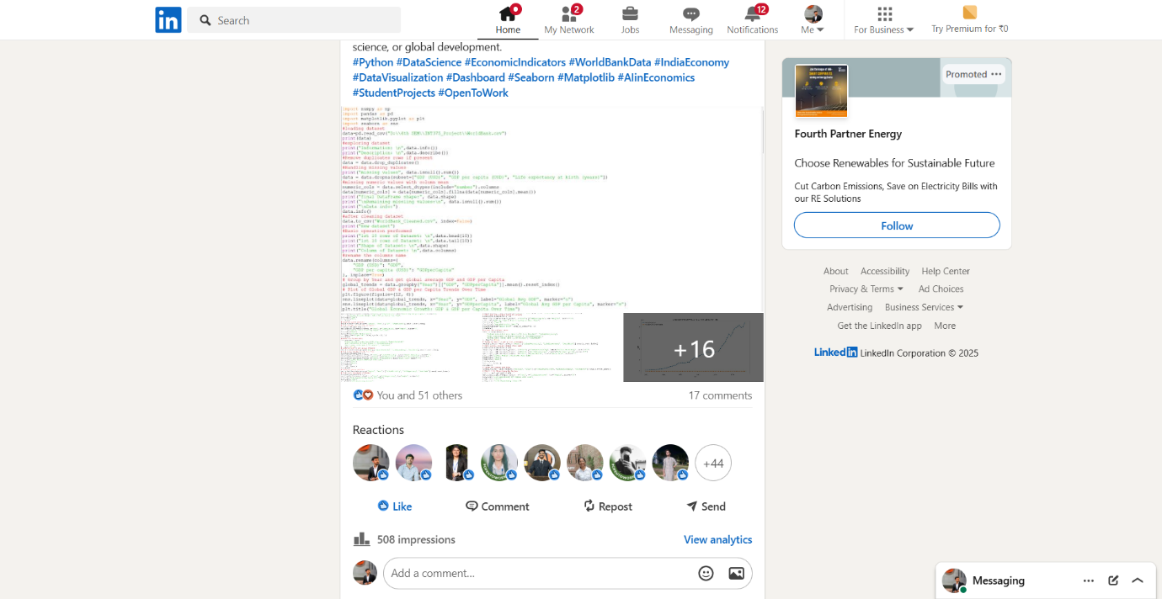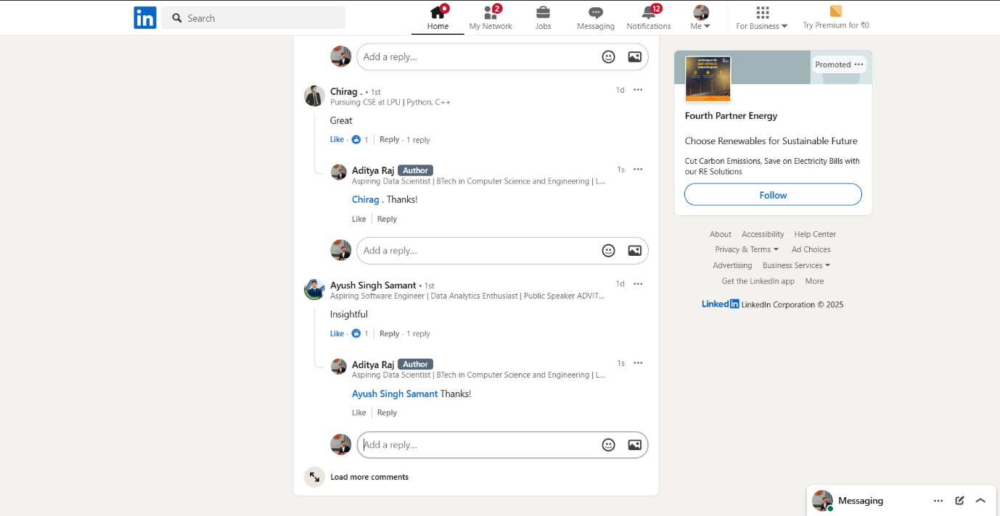

# ****9.GitHub Screenshot:****